MASCHERPA Audric ROB 3 2022 / 2023

**POLY-SNAKE**

**Weekly report n°8 from 14/12/22 :**

During this session, my partner and I focused on programming the movement of the snake so that it could be controlled using a joystick.

Thus, we designed its movement so that it can turn left or right, that it can turn around and that it can oscillate more or less quickly with a greater or lesser amplitude.

Here the Github link of the program : <https://github.com/YOUSSNDR/PolySnake/blob/main/programmes/servomoteurs/D%C3%A9placement/transition%20sw-line/transition%20sw-line.ino>

Here the youtube link of the video of the test of the program : <https://www.youtube.com/watch?v=qZ7Id3EbTI4>

Figure 8.1

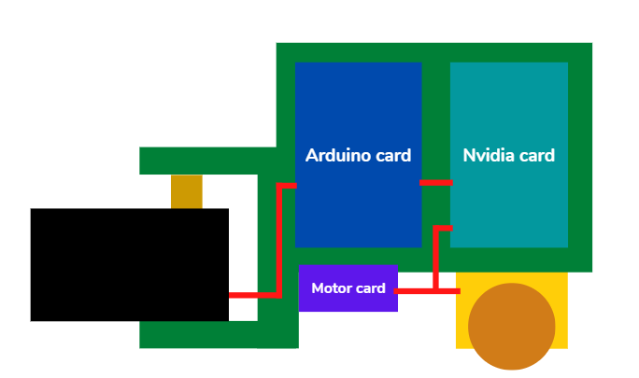Once this step is completed, I focused on modeling the head of the snake which will have to accommodate: The Nvidia card (light blue), the Arduino card (dark blue), the motor (in yellow), the control card of the motor (purple) and finally the servo (black) in Figure 8.1.

It’s important to highlight the interest of the engine which will allow the PolySnake project to move forward using two motorized wheels and not just stand still as can be seen on the Youtube video above.

Thus, the motor card will control the motor, the Arduino card will control the servomotors and the Nvidia card will be the intermediary between all these components.

Finally, the snake will be able to use the servomotors to imitate the movement of a real snake while the two motorized wheels at the front will allow it to move forward as in Figure 8.2 which is a diagram of what will look like the final project.

Figure 8.2

